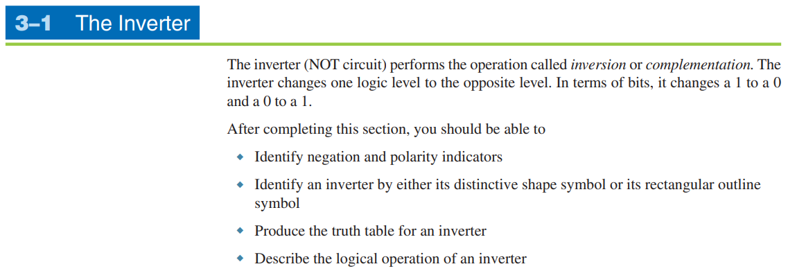

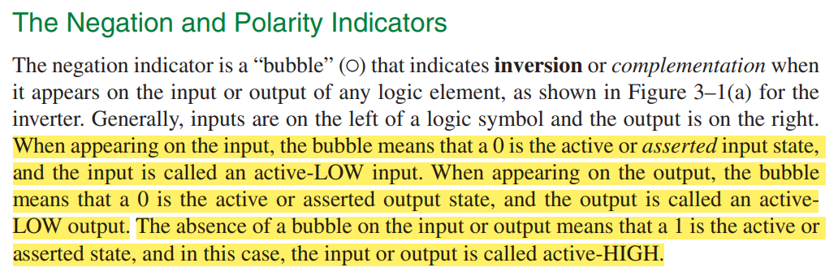

In digital logic design, the placement of the bubble symbol (representing negation or inversion) at the input or output of a gate does not change the logical operation performed by the gate. The inversion affects the signal either before it enters the gate (at the input) or after it leaves the gate (at the output), but the overall logic function remains the same.

Active state is 0 = the 1 is 0 (inverted or asserted) Not asserted = 0

* When the input signal is "asserted" or activated, it means it is at a HIGH level (logic 1).
* When the input signal is not asserted, it means it is at a LOW level (logic 0).

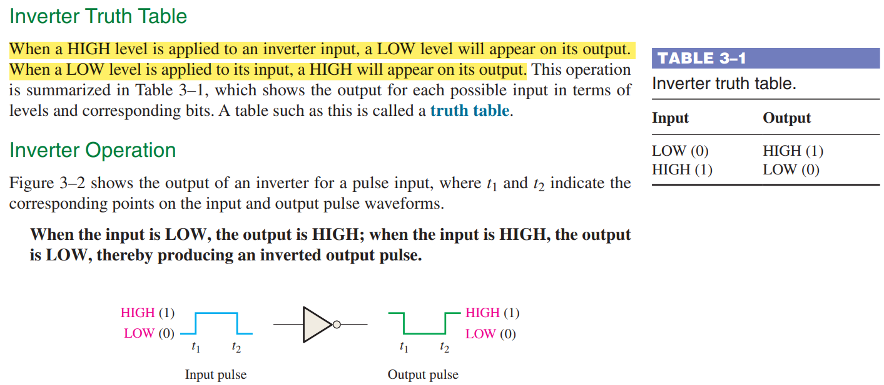

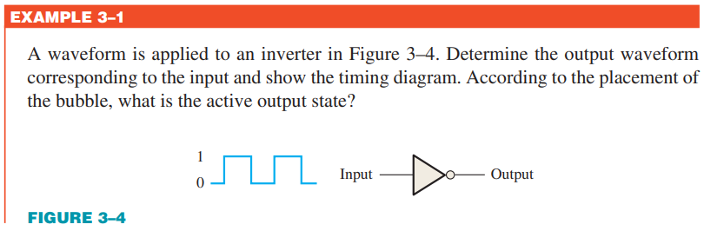



**Related Problem:**

The placement of the inverter with the negative indicator on the input instead of the output can affect the timing diagram by introducing additional delays associated with the inverter's propagation delay.

1. **Inverter at the Output:**
   * When the inverter is placed at the output of a gate, the output signal is inverted after the internal logic operation is performed. In this case, the timing diagram would show the delay introduced by the gate's propagation delay, which is the time taken for the output signal to respond to changes in the input signal.
2. **Inverter at the Input:**
   * When the inverter is placed at the input of a gate, the input signal is inverted before it enters the gate. In this scenario, the timing diagram may show a delay in the input signal reaching the gate due to the propagation delay of the inverter itself. Additionally, the timing diagram may also show the effect of setup and hold times for the gate, which are critical for ensuring reliable operation in synchronous digital systems.



